**Summary:**

To get familiar with spreadsheets, you should consider a spreadsheet’s format:

* Each rectangular block is a cell.
* Each cell is meant for one data point, just like in the table you created previously.

Now, consider the cells that run across the top of the spreadsheet (horizontally) and along the left side of the spreadsheet (vertically):

* Cells are organized by columns and rows.
* Each column has a distinct letter, and each row has a distinct number.
* Each cell has a unique identifier composed of the column letter and row number. This identifier is like the cell’s address.

*We have already covered the theory portion already and It’s pretty basic and I already have hand written notes so I won’t be getting in detail here*

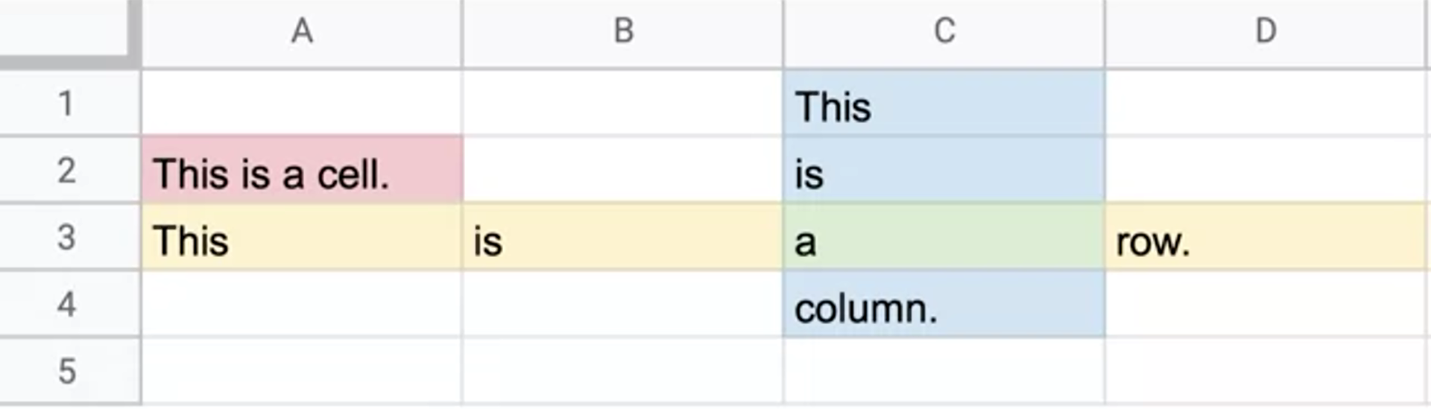

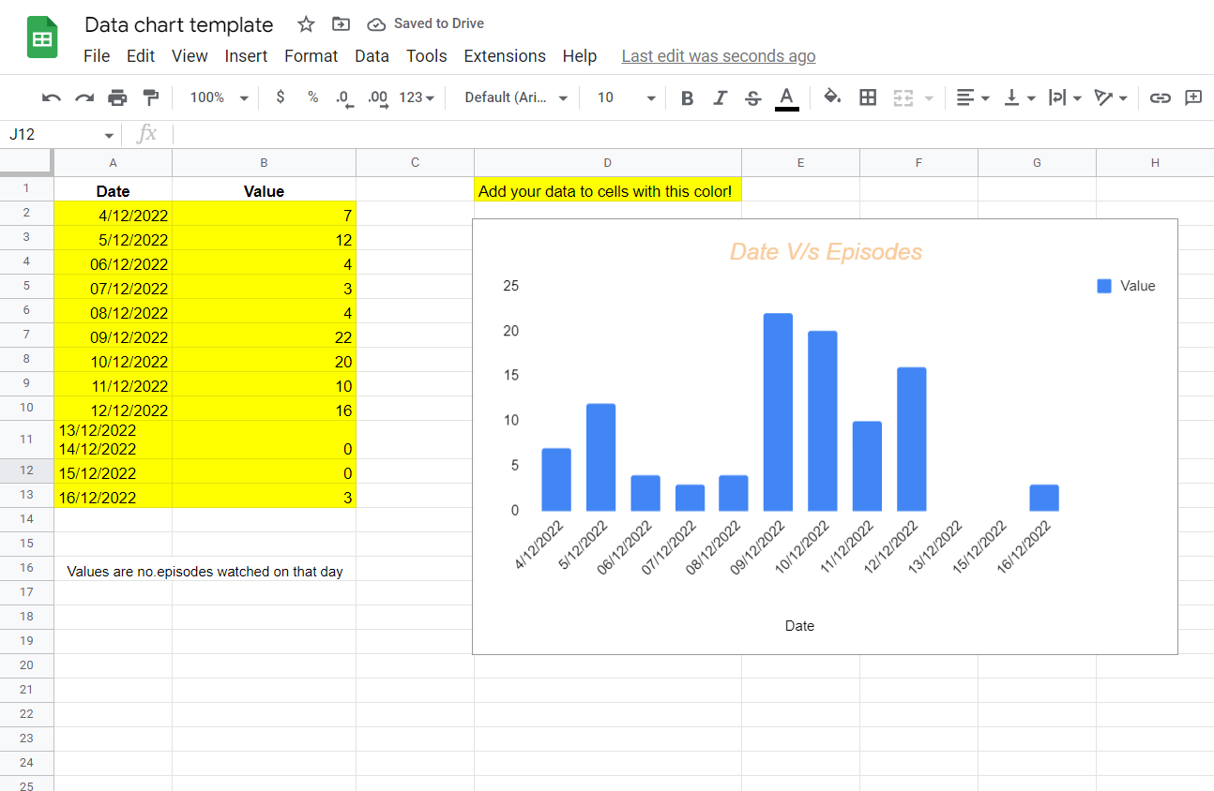

*You have come a long way! You started recording your data manually, you loaded that data into a spreadsheet, and you visualized the data in a chart. Now, take a moment to examine your completed data visualization. In the text box below, write 2-3 sentences (40-60 words) in response to each of the following questions:*

* *How did you use a spreadsheet to help prepare your data?*
* *How did you format your chart to help you analyze your data?*

***I filled the data I collected a while ago, the data describes how many episodes I watched on particular dates. This data can be used to calculate figures such as average screen time, predict how many episodes I'll watch in future, etc. I already know how to make a spreadsheet so It was a piece of cake. I formatted it in ascending order according to data to help me analyze it better.***